Human Computer Interactions

# Guardians of the Media

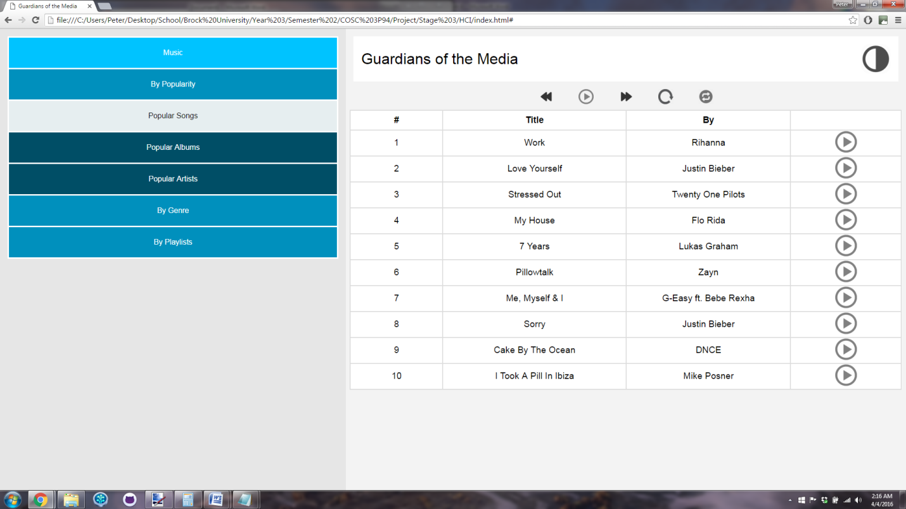

## What is it

“Guardians of the Media” is a web based media player seemingly designed primarily for the use of playing audio files and music albums. The interface is minimalist to promote usability over feature overkill which leads to a website that is easy to quickly determine how it functions and controls.

The application intentionally doesn’t give users many options. The options that are there include sorting the media based on a number of categories, each of which also have sub-categories. These categories are: By Popularity (which includes subcategories: Popular Songs, Popular Albums and Popular Artists) as well as By Genre and By Playlists. One would assume that there are also Sub-Categories for the other main categories as well but those are not listed on the current version of the website. Another assumption this reviewer is making is how the sorting categories may function on the actual product. Currently, the "By Popularity" option has 3 sub categories (which are noted with a different, darker blue) with the "Popular Songs" sub-category being a different grey colour. It is assumed that only the sub-categories for popularity are shown because the user selected that category. If the user selects by Genre, those options may go away and sub categories related to Genre will show up. Finally, it is assumed that the grey coloured option is to denote the currently selected option. These assumptions are necessary since the functionality did not need to be complete for this stage of the assignment.

To the right of the menu is the media player section of the website. This portion breaks down into 2 main parts which include the music controls and the song listing. The media controls have a number of standard options that use familiar, recognizable symbols to denote what each does. There is the option to skip backwards to the previous song, play the song current song, skip to the next song. The next two options are less obvious. Those are followed by a circle symbol that I have never seen before. The image file states that it is the 'replay' button so I imagine the function is to replay the current song. That is followed with the button that I am familiar with. This icon is the icon typically used to denote replaying the song, however, in this case it is used for shuffling the list of songs.

Below the controls is the song listing. This gives a table view giving the song number followed by the title and artist of the song. Following each song is also a play button to play the song. It is unclear in this application whether or not this is a playlist the user created or if this is every song in the user’s library. How it is currently, the user cannot change the order of this list, nor can they sort the list within the table.

The simplicity of the application makes it easy to quickly determine how if functions and makes it incredibly easy to use for those who just want to use it to listen to their music. The lack of clutter on the page makes it portable to smaller screens while allowing you to get to your music in as few clicks as possible. The selected colour palate is also easy on the eyes and inviting to users making it a welcoming environment to listen to music.

## Interaction Problems

For the purposes of this critique, the term "Interaction" specifically refers to the Gulf of Execution and Gulf of Evaluation. This would be the back and forth communication between the user and the system. In this case, I will begin with what I liked about the interface in that regard.

What this interface does well is noting which items on the screen are selectable. When hovering over the menu items on the left of the screen they all change colour to note that it is a selectable option. Additionally, the user's pointer turns into the selection icon (the one of the hand pointing with its index finger) which helps to further define the select-ability of the object. When the object is selected, it turns grey in the menu to visibly indicate this selection. Another instance where this is apparent is in the media options at the top right of the screen. Once again, when the user hovers over the buttons, the pointer changes to the selection icon making it clear that the user can click on those icons.

Though it is clear which buttons are selectable within the interface, much of the interaction problems stem from determining what the buttons actually do. For the media controls section, the first 3 options are clear since they are universal to all media players but the next 2 options are less so. I will discuss the selection of the icons more in the "Design Miscues" section but for the buttons themselves, I was unable to determine exactly what they did without looking at the name of the image stored in the directory structure. Additionally, it is unclear how the 'play' button beside the individual songs will function without first trying it out. Will it play that song followed by all the songs below it? Will it just play the song I selected and then stop? If so, how would I then play the entire playlist?

Another Interaction issue spawns from the music table itself. The table could use a similar highlighting feature on hover that is seen in the menu items. It will make it more clear which song you are looking at (helpful if you intend to add more columns to that list) and ensures that the users know that item is interactable. This could also be helpful in displaying the currently playing song as that can be a different, potentially darker, colour than the on-hover highlight. Additionally, if there is the option to sort the table that should be more clear. This can also be accomplished with on-hover highlighting, again, with the selected column appearing as a different colour. You would also need to include the direction it is ordered in, i.e. ascending/descending. This can be done in the standard arrow up and arrow down.

Finally, a quick comment on the circle at the top right corner of the page. It is unclear exactly what the function of this button is. It appears to be the logo of the application. If this is true, it is common for the logo of a website to redirect to the homepage of said website. However, there is only one page in this site so would it just refresh the screen? Reset the user option? Clear the playlist? Maybe a more clearly defined option would be more helpful here.

## Logic Problems

In this section, I will discuss functionality that hasn't been adequately defined in the application (which I will refer to as logic gaps) as well as portions of the application that don't fit the "logical mind map" created from the appearance of the interface.

There are a number of features that are not well enough defined within the application as is that bring up legitimate questions. Since this is a static page, much of these questions have to do with the navigation to music and how the site will work with larger data sets. I will start with playlists since there is a filter/sort by playlist option. Would these be the user’s personal playlists or those generated by other users? In any case, there is no clear way to create a playlist. It would be handy to quickly add the currently playing song or a song in the table into an existing playlist.

The album and artist selection functionality is also a logic gap for the current incarnation of the site. If one were to select the "Popular Artists" or "Popular Albums" in the left menu, would they be presented a similar list of songs, this time sorted with popular artists/albums first or would you be able to select the albums and "Drill Down" to specific songs? How will the site handle a large data set of songs, will I need to scroll through all the songs to find the one I am looking for? How does the popularity work? Is it, "Popular for me" as in songs that I listen to a lot, or is it "Popular for everyone" as in songs that are commonly played by the majority of the users. Also, it is unclear the source of the song listing. Is it songs that are streamed online or does this somehow access my local directories and this is just songs currently on my computer? The majority of these logical inconsistencies could have been addressed by adding the pages for those options so I would recommend adding similar interfaces for all of these menu item options.

As far as inconsistencies with the "mind map" for using the application, there are some issues that arise from the media table and the media options on the right side of the screen. As mentioned in the previous section, it is unclear how the play button beside each song functions. It would make sense that I am selecting play on that specific song to just play that specific song. In that case, I would need to hit play for every song I wish to listen to immediately following the finish of the previous song. It is common in media players to have the next song play after the current song is finished, if this is the case, that would mean to play an album or a playlist, I would be required to open the playlist and press play on the first song. This performs the function that I want but is logically not achieved in a way that is representative of my goal state. If I wanted to play all items in the playlist, there should be a play playlist option at the top of the list. That way there is a clear solution the task of playing the entire list.

## Design Principle Miscues

This section specifically looks at the design principles learned in class and tries to note where this application success and fails at following those guidelines. This application as a whole sticks fairly close to the discussed design rules but there are a number of areas where it doesn't quite line up.

First, I will discuss where the Guardians of the Media application succeeds in terms of design principles. The menu on the left of the page is clean and limits its options to an acceptable number. It doesn't overload the user with options and does so in a way that is easy and inviting to use. By hiding the subcategories, it adds an extra click before actually selecting an item but also works in simplifying the menu and keeping it from providing too many options. Another positive aspect comes from the application’s use of colour. Colour is used sparingly here and where it is used, it is used for a purpose. Colour distinguishes categories from subcategories, it notes which items are selected and it divides sections of the application. It uses the colour Blue well, which is noted for its relaxing properties, and opts to use shades of blue instead of different colours (which helps usability for those that are colour blind). The application is well designed on a whole, however, there are a couple design miscues that need to be addressed.

These design miscues for the most part relate to the un-clarity of the current ‘state’ of the application. The menu uses a grey colour to note which option is selected but the media player itself has no indication to what state it currently is in. This is indicated specifically in the media player controls. There is no way of telling which song is currently being played. This could be resolved by adding a song title above the player or highlighting the currently playing song in the list (or both). It is also unclear which song will play next when you hit the skip next button on the player. This is especially true if you leave the current menu to find a different song to play. There should be an easy way to go back to the current playlist and see the list of songs you have coming up.

A number of other design miscues appear in the menu portion of the application. Though there is the aforementioned colour distinction to differentiate the categories from the subcategories, it doesn't do a great job showing that they are actually children of the parent menu item. Something that would make this clearer would be to indent the sub categories. This is a standard approach to designing menus and is something users would instantly recognize, which would also make the function of those options more clear. Additionally, the colour of the selection option may not be the best choice to define the selected distinction. Grey is often a colour associated with an option being disabled and may lead the users to assume that it is just unselectable. Changing the colour and potentially bolding the selected menu item may do a better job of displaying this information. The headers on the music table, as well, blends into the list of songs, keeping them for standing out as something separate. It may be a good idea to add colour to the table headers to make them more distinct.

Finally, as mentioned in a previous section, there are a number of design issues with the icons chosen for the media player options. I mentioned previously that the functions of the options were unclear but that is mainly due to poor choices for the icons themselves. In this case, the replay button is represented by a circle icon that I am unfamiliar with. It makes sense that the icon chosen would mean replay since it is similar to the common replay button but the confusion is compounded since the icon directly to the right of it IS the replay button that is standard in most user interfaces. Here, the standard replay button is used for the 'shuffle' function. Design principles state to use icons that are familiar and immediately recognizable and in this instance I would say they are not. Additionally, the play button is a dark grey colour while the other buttons are black. This would have the user assume that the play button is not selectable. If the button wasn't selectable, it wouldn't make sense to then still allow the user to perform any of the other actions in the media control. However, If the play button is selectable, then if is a poor choice of icon colour that needs to be corrected.

## Usability Issues

Usability issues refer to the problems with the interface that make it difficult to navigate or control leading to frustration from the user. The simplistic design of the Guardians of the Media application certainly helps the usability factor of the application but there are a number of features that are missing that can cause a problem for the finished interface.

The biggest missing feature is the lack of a search bar. This is a massive problem since as it stands, finding a single song is incredibly tedious. If a user is looking for a specific artist or song, they currently need to select one of the available filtering options and then scroll through every potential option until they find the item they are looking for. This manual searching isn't a huge deal if the user only has a handful of songs in their collection, but what if the dataset increases to thousands or millions of songs. A manual search would be completely unfeasible in that case.

Another feature that can help usability would be the ability to re-order the songs in the playlist. It makes sense when listening to an album to listen to that in the order it was presented, however, if the user is listening to just a random assortment of songs, the user should be able to remove and re-order songs at a whim. If there is a song later in the playlist that they wish to listen to now, it makes sense for them to be able to move it to next in the song order without having to manually jump down and then jump back up. Additionally, if the user is listening to a song from an artist they like, they should be able to quickly access the rest of the artist’s songs. This can be remedied by the inclusion of a search bar but a cool solution would be the ability to select the artist within the song list and have it link directly to the artist’s page, or at least a list of songs by that artist.

Finally, there is currently no easy way to find and play new music. It is common for media users to want to listen to the newest songs first, be that songs they just recently downloaded or song that were just recently released. To simplify the discovery of these songs, it would be helpful if there was a 'new songs' menu item that gives a list of songs ordered by the download date or release date.

The application currently very usable for a small number of songs, however once that number of songs increases, I forsee it running into a problem where the simplicity of the app becomes more of a problem than a help.

## Suggestions for Improvement

All of the change suggestions were provided throughout the report but here is a table to clearly note the aforementioned suggestions:

|  |  |
| --- | --- |
| Change | Reasoning |
| Button titles on hover | This will make it more clear the functions of each button without requiring the user to click the button |
| A play all button for a playlist | This will make it more clear that you are playing every song in the playlist instead of using the resulting effect of playing the first song |
| Double click to start song | It is standard in media applications to start a song on double click. This may be more user friendly than a play button for each song |
| Sort the song list table | Using the table headers to allow the users to sort the list of songs can help users more easily locate songs the wish to listen to |
| Change row colour on hover | This will help note that the songs are selectable and will give the table a more interactive feel |
| Indicate the song that is currently playing | You can do this both by displaying the name of the song above the media control as well as highlighting the currently playing song in the table |
| Add a way to create playlists | It's not clear how this is done nor how they are edited |
| Add an album and artist select menu | Finding artists and albums should function differently than finding songs since they are different actions |
| A back to playlist button | This can allow the user to explore the library and then go back to the list of songs that are currently being played |
| Indent the sub-menus | Makes it more clear that they are submenus |
| Change the colour of the selected menu item | Grey stands for unselectable. This can lead to confusion |
| Add a search bar | Allows people to more easily find specific songs |
| Song reordering | Allow them to change the playlist on the fly to listen to the songs they want to hear |
| Quick link to artist page | User should be able to select the artists name in the table and get more songs from that artist. |
| New Song List | An option to only get the newest songs. These are songs user will often want to play first |

## Rating

(3 1/2 out of 5 stars)

The Guardians of the Media - media player is a well designed application that uses simplicity to its advantage to create something that is instantly understandable and usable without much in the way of training or prior knowledge. The use of colour leads to an inviting interface that I can easily see myself using for long periods of time. As it stands now, however, there are too many questions that keep it from getting a higher score.

It is unclear how the application will function with a large number of songs and it doesn't appear to be geared to that. Locating and navigating a large data set seems to be a chore with the application as it is now. Additionally, too much of the app remains unfinished for me to give a complete review. How do the other menu options function? Does selecting the album option give me a different album view or is it similar to the song view listed. If it is the same, this can lead to confusion since those are essentially 2 completely different tasks being tackled in an identical way.

In all, it is a slick application that just needs a little more thought on how it will work on a larger scale.

## Comparison

There are a number of things that I really like about this application that I wish my group utilized in our solution, a lot of which I mentioned throughout this critique. I liked the simplicity of the application. Something that I now see about our application is we tried to cram a lot of features (or potential features) into the interface that it does seem overly complicated. This interface shows much of the benefits of pairing back and leaving only essential features. Another thing that they did better was the colour palate. Our group focused on the real life metaphor and as a result relied too much on realistic images and backgrounds. There is a lack of whitespace in our app that this application clearly takes advantage of. It also does a better job of denoting what is selectable, something that we will change for our next submission.

With that said, I feel like this application is lacking some essential features that keep it from being a completely usable media player. By including some of the on the fly playlist creation as well as fleshing out their player a bit more in the way we did I think this app could be super usable and user friendly.